22nd May 2018

**FIA World Touring Car Cup Race of Netherlands at Zandvoort**

Jean-Karl Vernay completed a memorable weekend for the WTCR – FIA World Touring Car Cup with victory in the third of three races at Zandvoort, The Netherlands, where 110,000 fans – including Dutch Formula One star Max Verstappen – were in attendance.

The FIA Series which has premium Japanese tyre manufacturer YOKOHAMA, as exclusive tyre supplier witnessed Vernay’s Audi Sport Leopard Lukoil Team forced into an overnight engine change following the Frenchman’s fifth place finish in Race 1 on Sunday. But Vernay, who was penalised by starting Race 2 from the back of the grid, repaid his team’s hard work by claiming the Pole Position for Race 3 on Monday morning and then converted his top start spot into a victory later in the day.

After Yann Ehrlacher took the Race 1 laurels at WTCR Race of Netherlands, it was the turn of his fellow Frenchman Aurélien Comte to savour the limelight with his maiden victory in Race 2 to become the eighth different winner of 2018 following a brilliant drive.

Comte, in a DG Sport Compétition Peugeot 308TCR, was second in Race 1 ahead of Rob Huff and Gordon Shedden but went one better in Race 2 by beating James Thompson’s Honda Civic Type R TCR off the line in the reverse-grid counter. It means five racing brands have now won in WTCR. Ehrlacher finished second after being handed the place by his All-Inkl.com Münnich Motorsport team-mate Thompson to boost his title bid.

Huff was back on the podium in Race 3, taking his Sébastien Loeb Racing Volkswagen Golf GTI TCR to second place ahead of Frédéric Vervisch, who hit back from a double driveshaft failure to claim third spot for Audi Sport Team Comtoyou.

Ehrlacher, now heads the drivers’ championship by nine points over Yvan Muller, his uncle and the most successful driver in touring car history. But while Ehrlacher celebrated, Muller endured a weekend to forget with the Hyundai i30 N TCR unable to match its early-season pace following adjustments to the Balance of Performance. Muller’s YMR team also faced a lengthy repair job to get the veteran racer back on track for Race 2 after he came off worse in a collision with Norbert Michelisz.

Dutch WTCR regular Tom Coronel scored a weekend-high of seventh in Race 1 as Pepe Oriola settled for fourth in Race 2 ahead of Mehdi Bennani. Esteban Guerrieri battled through to fourth in Race 3 with Shedden fifth. Wildcard Prince Bernhard van Oranje completed all three races.

**Driver Standings**

1. **Y Ehrlacher 146**
2. **Y Muller 137**
3. **R Huff 130**
4. **JK Vernay 121**
5. **G Tarquini 118**

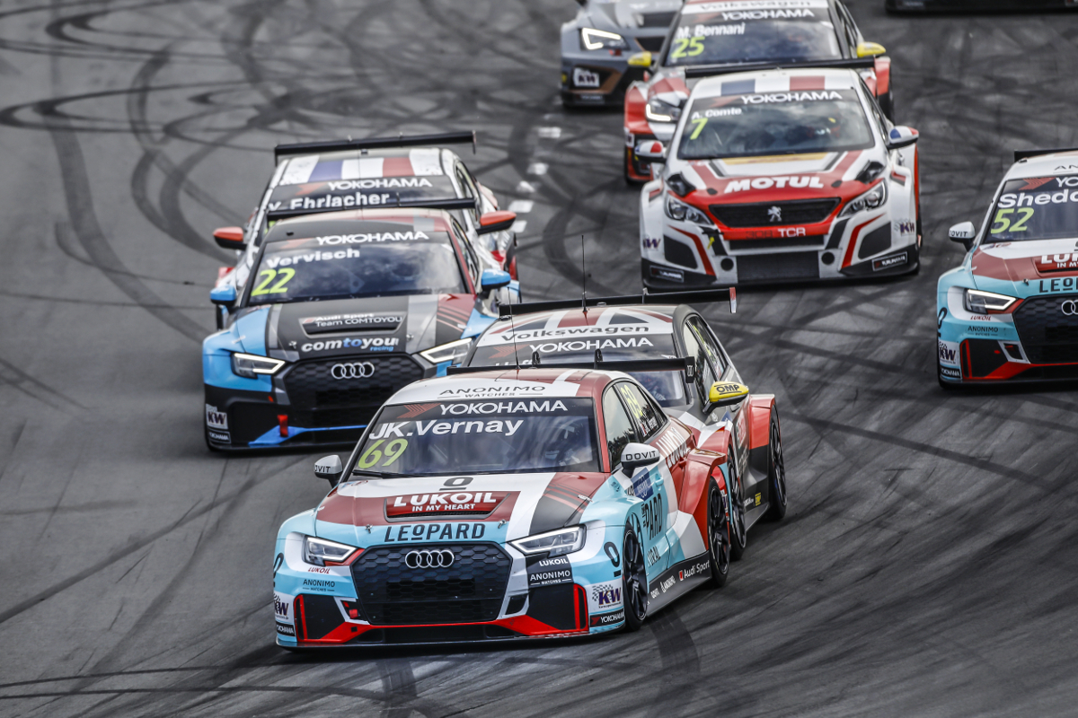

*Superb driving from Vernay - Photo by Francois Flamand*

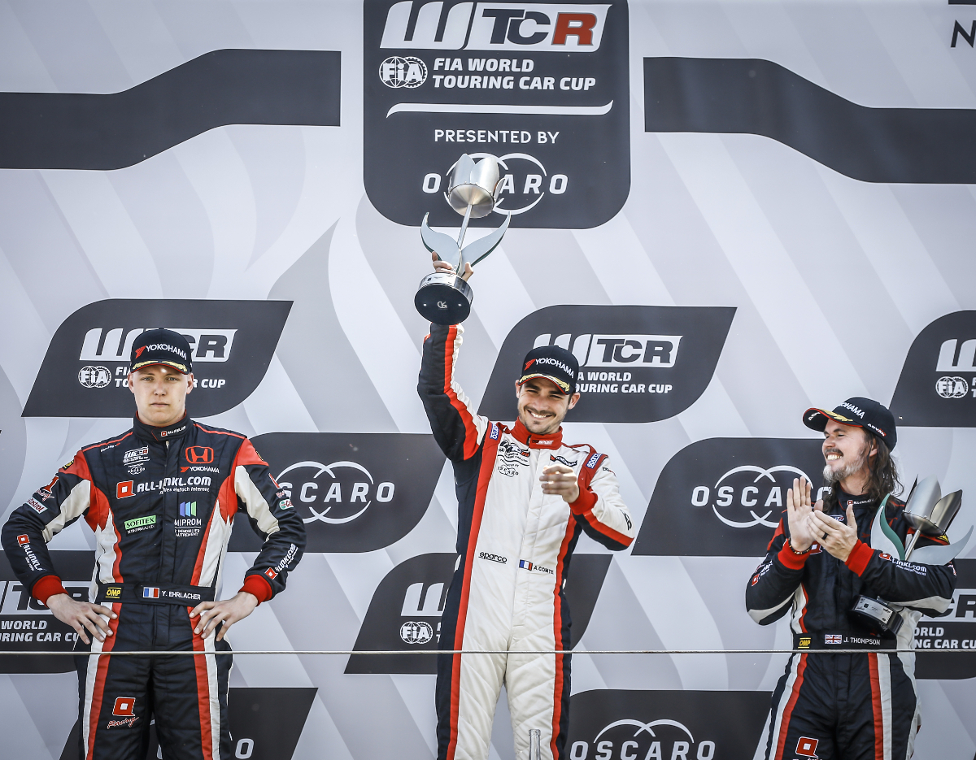

*Ehrlacher leads the FIA WTCR and celebrates podium - Photo by Jean Michel Le Meur*